### 

**Head of Learning & Development**

**Reporting to Group CPO**

Europe's leading online grocery delivery service. Using technology to deliver weekly shopping (17 000 SKUs) in less than three hours in 15 minute time slots, saving our customers time and giving them freedom and flexibility.

The world needs a better food system, one that is more sustainable, more inclusive and which brings healthier and more personalised food to all. Rohlik Group is leading this change. In every city we carefully select the best quality and freshest local produce to save our customers time; from butchers to bakery, and fresh produce directly from farmers via our unique Farm-to-Door program. We carry all the favourite brands, plus a range of affordable own-label products, so our customers don’t miss out on what they love.

### **Role Overview**

As the Head of Learning & Development, you will be a key driver of Rohlik Group’s talent strategy, partnering with the Chief People & Culture Officer and senior leadership to develop and implement an innovative, results-oriented learning and leadership development strategy. You will create impactful programs that inspire and grow our people, enabling them to thrive in a fast-paced, high-growth environment. With a focus on driving measurable outcomes, you will foster a culture of continuous learning, ensuring Rohlik remains an employer of choice.

### **What we expect from you**

### Strategic Learning Leadership Develop a long-term, scalable Learning & Development strategy aligned to business priorities, fostering leadership excellence and technical mastery across the organization.

* Leadership Development  
  Create and execute leadership programs that build internal talent pipelines and prepare future leaders to drive growth and innovation.
* Performance and Talent Management  
  Implement and oversee robust performance management, talent assessment, and succession planning frameworks that drive a high-performance culture.
* Cultural Stewardship  
  Reinforce and integrate Rohlik’s leadership values and behaviors within the Group and Country leadership teams, nurturing a culture of excellence, collaboration, and inclusivity.
* Innovative Learning Programs  
  Design, pilot, and roll out innovative, high-impact learning experiences across diverse geographies, utilizing both in-person and digital formats to engage employees effectively.
* Continuous Improvement  
  Evaluate, enhance, and scale existing development initiatives to match the organization’s rapid growth and evolving needs.
* Vendor Management & Budgeting  
  Lead the selection and management of external training providers, ensuring high ROI while maintaining budget efficiency.

### **What we look for**

**Experience:**

* 7+ years of experience in Learning & Development roles, with at least 3 years in senior or head-level positions in international, high-growing multi-country environments.
* Proven track record in designing and delivering impactful learning programs that achieve tangible business results in entrepreneurial or scale-up context.
* Clear examples of L&D programs that drove tangible performance improvements, employee engagement, or eNPS gains.
* Cross-functional exposure: Familiarity with various business areas (e.g., operations, product, tech, HR) to create holistic, relevant learning initiatives.

**Skills:**

* Strong project and stakeholder management skills, including managing complex initiatives across diverse teams and geographies.
* Exceptional communication and interpersonal skills, with the ability to influence at all organizational levels.
* Strategic thinker with a deep understanding of business priorities and their alignment with talent strategies.
* Adept at leveraging technology to create innovative and engaging learning experiences.

**AI & Technology Integration**

* Digital Learning Expertise: Experience implementing or creating tech-enabled L&D solutions (e.g., adaptive platforms, AI-based coaching tools).
* Forward-Thinking: Eager to pilot emerging technologies, including AI-driven content creation or automated learning pathways.
* Change Management: Ability to guide stakeholders in adopting new technologies and upskilling for digital transformation.

**Mindset:**

* + Passionate about continuous learning and people development.
  + Hands-On Builder: Comfortable operating with minimal structure, taking full ownership to drive initiatives from ideation to execution.
  + Creative and forward-thinking, eager to challenge norms and set new trends in L&D.
  + Agile and results-driven, comfortable navigating a high-growth, fast-paced environment.

**Language:**

* + Fluency in English is essential; additional language skills are a plus.

**KPI**

* Your success will be measured through:
* The number and impact of learning and leadership development programs delivered.
* The growth of internal talent pipelines and identified successors.
* Improvement in eNPS and employee engagement scores.
* Implementation of digital and innovative learning solutions.
* Feedback from stakeholders and alignment to business outcomes.

### **What we offer**

* Be a strategic leader shaping the future of a high-growth, billion-dollar unicorn.
* Have the autonomy to implement meaningful and innovative ideas without excessive bureaucracy.
* Work in an environment that values innovation, agility, and measurable impact.
* Access to competitive rewards, continuous professional growth opportunities, and the chance to truly make a difference.
* Your work will have a direct impact on the company's results
* We will implement your good ideas almost immediately – not waiting for the approval of the headquarters somewhere in the world
* You will not be bound by corporate processes
* Your work has to be innovative and meaningful, we do not want to follow trends, but set them
* Last but not least, we mainly offer a fair reward and the possibility of professional growth and education, also a great bunch of people around and a legendary company events

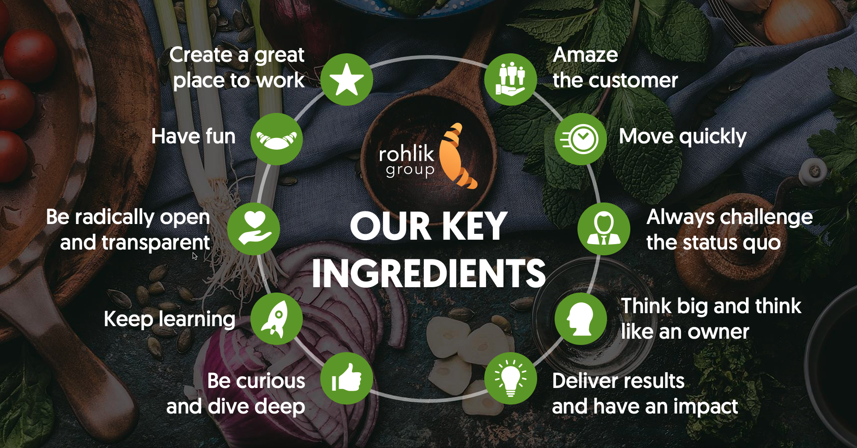

Key responsibilities

* Develop & Own the L&D Strategy
  + Scale-Up Focus: Build and continuously refine an L&D roadmap aligned with rapid growth and evolving business priorities.
  + Integrated Approach: Ensure that learning solutions support strategic areas like leadership readiness, problem-solving, and innovation.
* Design & Deliver High-Impact Learning Programs
  + Core Curriculum: Create leadership and functional development pathways, with special focus on empowering teams in Group HQ and German HQ.
  + AI & Tech Integration: Leverage AI-driven platforms, micro-learning, and blended solutions to increase engagement and speed to competency.
  + Pilot & Iterate: Test new learning concepts (e.g., gamification, peer coaching) quickly and scale successful initiatives.
* Foster a Culture of Ownership & Problem-Solving
  + Peer-to-Peer Learning: Establish mentorship, coaching, and knowledge-sharing communities to promote continuous development.
  + Skill-Building for Problem-Solving: Implement training and workshops on frameworks (Design Thinking, Agile) to enhance employees’ analytical and creative capabilities.
* Partner with Stakeholders & Drive Alignment
  + Cross-Functional Collaboration: Work closely with leaders in Operations, Product, Tech, and HR to identify skill gaps and co-create solutions.
  + Influence in a Flat Structure: Build strong relationships and champion L&D initiatives without relying on hierarchical authority.
* Talent Management & Succession Planning
  + High-Potential Development: Identify, assess, and accelerate growth for top performers, creating robust internal talent pipelines.
  + Performance Enablement: Oversee or collaborate on performance management processes to ensure alignment between individual growth and business results.
* Measure & Communicate Impact
  + Data-Driven Metrics: Establish KPIs (e.g., skill adoption rates, program engagement, eNPS improvements) to assess effectiveness of L&D initiatives.
  + Iterative Improvement: Gather feedback, analyze outcomes, and refine programs to continuously raise the bar and meet shifting needs.
* Champion AI & Digital Fluency
  + Upskilling Programs: Equip teams with digital and AI literacy skills critical for innovation and operational efficiency.
  + AI Integration in L&D: Stay abreast of AI trends, experiment with new tools, and embed them into learning solutions where they add real value.
* Culture Building & Advocacy
  + Living the Values: Embed Rohlik’s leadership values and problem-solving ethos in every learning touchpoint.
  + Internal Evangelist: Inspire teams at all levels to embrace continuous learning, experimentation, and a growth mindset.
* Adapt & Scale Globally
  + Local Relevance: Tailor group-wide programs to suit country-specific nuances (especially Germany), ensuring both consistency and cultural fit.
  + Scalable Infrastructure: Develop processes and platforms that can support rapidly growing teams across multiple geographies.